**American International University, Bangladesh**

Faculty of Science and Technology

**Introduction to Database**

**Project Name:** CRYPTOCURRENCY MANAGEMENT SYSTEM

|  |  |
| --- | --- |
| **Name** | **id** |
| Redip Biswas | 24-56526-1 |

**ER SCENARIO**

The Cryptocurrency Management System involves three main types of users: Admins, Brokers, and Clients. Admins are responsible for managing user accounts, verifying transactions, and ensuring system integrity. Brokers act as intermediaries between clients and the market, assisting in buying and selling cryptocurrencies. Clients can register, deposit funds, buy or sell cryptocurrencies, and monitor their portfolio. Each transaction is recorded with details such as transaction type, amount, date, and involved parties. Cryptocurrencies are maintained with up-to-date information like coin name, symbol, and current price. The system also tracks user balances and provides secure login credentials for all users. This organized structure helps in managing crypto trades efficiently while minimizing fraud and confusion, offering a safe and transparent platform for all participants.

ER Diagram:

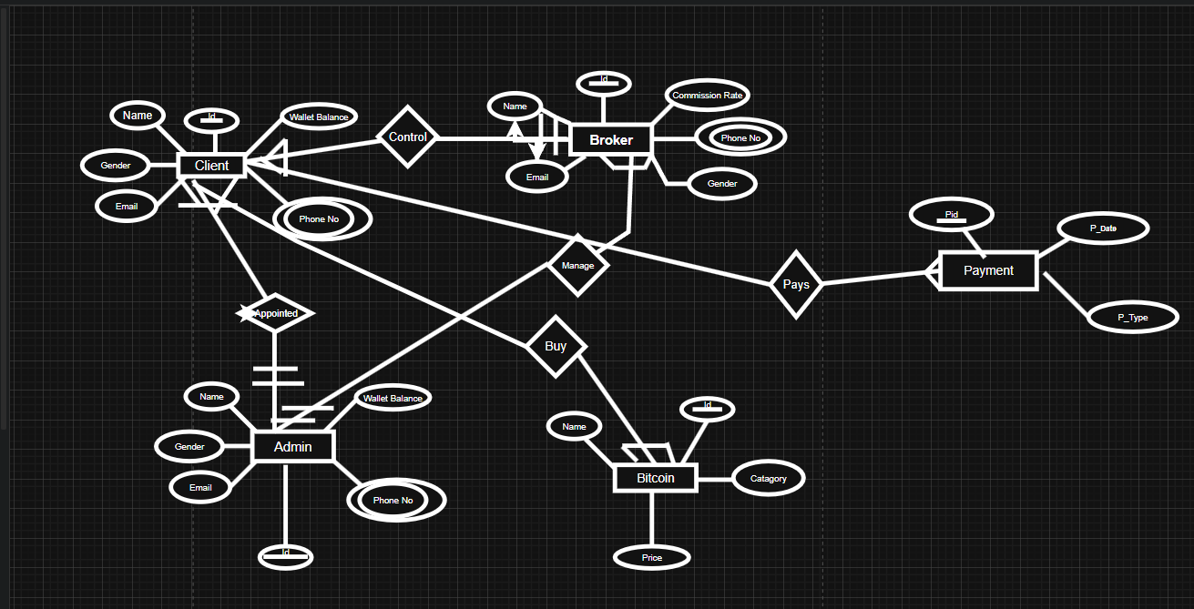

# Normalization

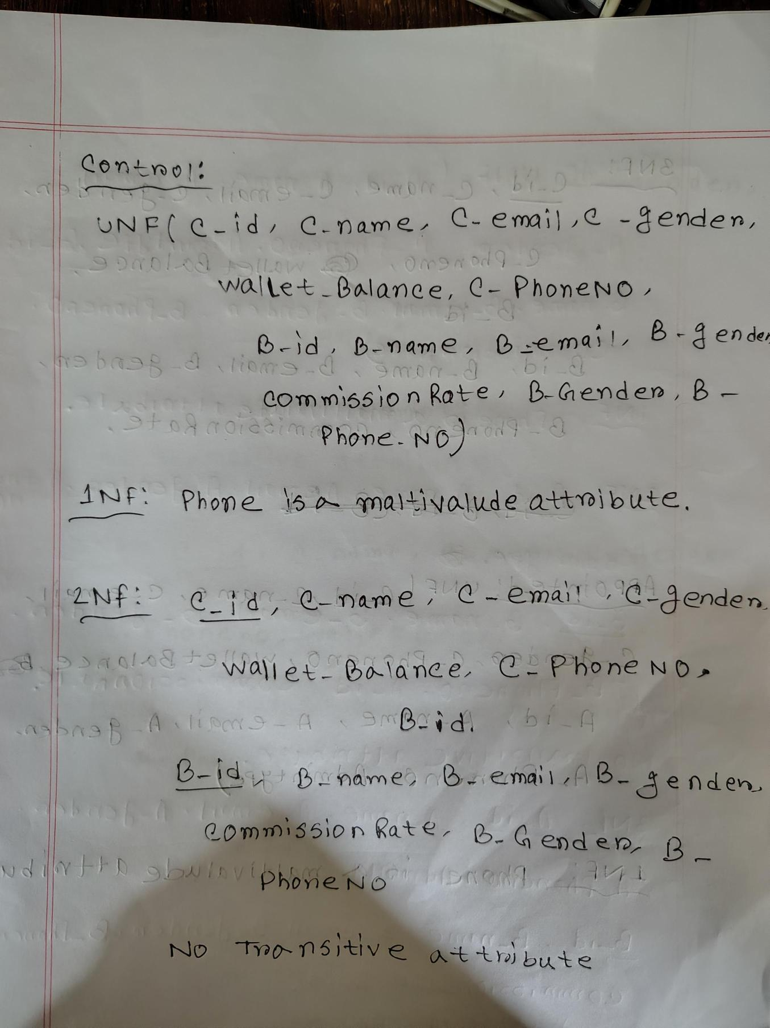**Normalization:**

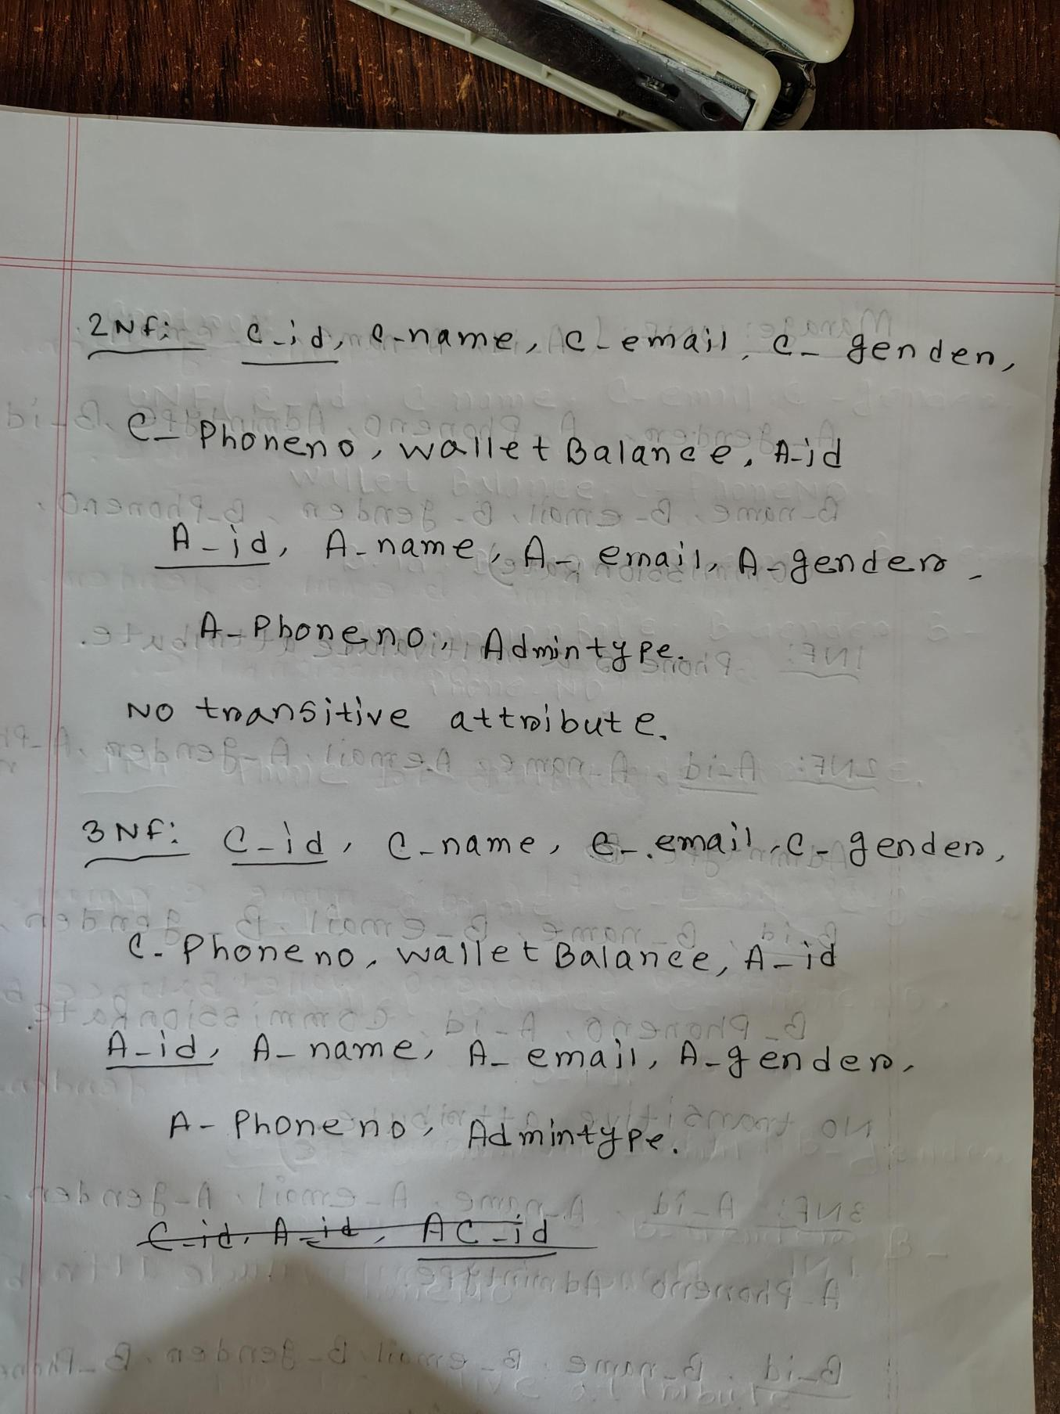

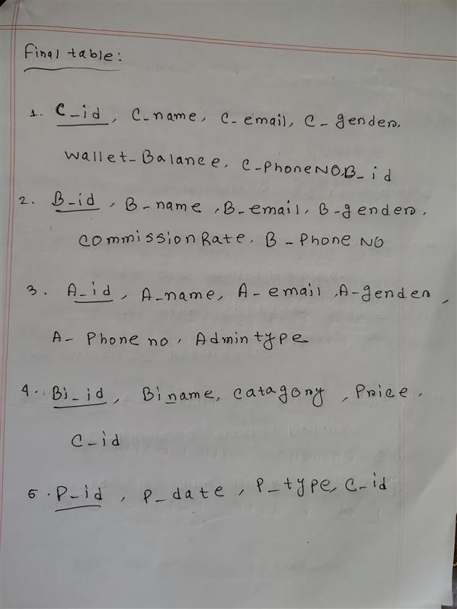

**Table Creation and Insertion**

1. create table Clients (c_id number (5) constraint client_cid_pk PRIMARY KEY,c_name varchar2(50),c_email varchar2(50) ,c_gender varchar2(50),c_phoneNo varchar2(50), wallet_balance number (8,2))

insert into Clients(c_id,c_name,c_gender,c_email,c_phoneNo,wallet_balance) values(102,'Rahul','Male',' rahul@gmail.com','019857447468',5888.98)

insert into Clients(c_id,c_name,c_gender,c_email,c_phoneNo,wallet_balance) values(103,'Piotry','Female',' piotry@gmail.com','01756258987',587456.98)

insert into Clients(c_id,c_name,c_gender,c_email,c_phoneNo,wallet_balance) values(104,'Prottoy','male',' sprottoy@gmail.com','018657995245',587.98)

insert into Clients(c_id,c_name,c_gender,c_email,c_phoneNo,wallet_balance) values(105,'Shad','male',' [shad@gmail.com','01865799794',58796.98](mailto:shad@gmail.com','01865799794',58796.98))

2. create table Broker (b_id number (5) constraint client_bid_pk PRIMARY KEY,b_name varchar2(50),b_email varchar2(50) ,b_gender varchar2(50),b_phoneNo varchar2(50), commissionRate number (8,2))

insert into Broker (b_id,b_name,b_email,b_gender,b_phoneNo,commissionRate) values (202,'Niddi',' niddi@gmail.com','female','018796542',10.9899)

insert into Broker (b_id,b_name,b_email,b_gender,b_phoneNo,commissionRate) values (203,’Roton’,’ roton@gmail.com’,’male’,’018796542544’,5.698)insert into Broker (b_id,b_name,b_email,b_gender,b_phoneNo,commissionRate) values (204,'Masud',' mas@gmail.com’,’male’,’01982489654’,7.69741)

insert into Broker (b_id,b_name,b_email,b_gender,b_phoneNo,commissionRate) values (205,’Manik’,’ [nik@gmail.com','male','01878963214',10.6971](mailto:nik@gmail.com','male','01878963214',10.6971))

3. create table Admin (a_id number (5) constraint client_aid_pk PRIMARY KEY,a_name varchar2(50),a_email varchar2(50) ,a_gender varchar2(50),a_phoneNo varchar2(50), Admin_Type varchar2(50))

insert into Admin (a_id,a_name,a_email,a_gender,a_phoneNo,Admin_Type) values (500,'Partho', 'partho@gmail.com','male','0178965412','Gold')

4. create table Bitcoin (bi_id number (5) constraint client_biid_pk PRIMARY KEY,bi_name varchar2(50),catagory varchar2(50), price number (8,2))

insert into Bitcoin (bi_id,bi_name, category, price) values (30, 'Bitcoin', 'Crypto',50000.981)

insert into Bitcoin (bi_id,bi_name, category, price) values (32, 'XRP', 'Crypto',70000.981)

insert into Bitcoin (bi_id,bi_name, category, price) values (33, 'Tether', 'Crypto',500569.981)

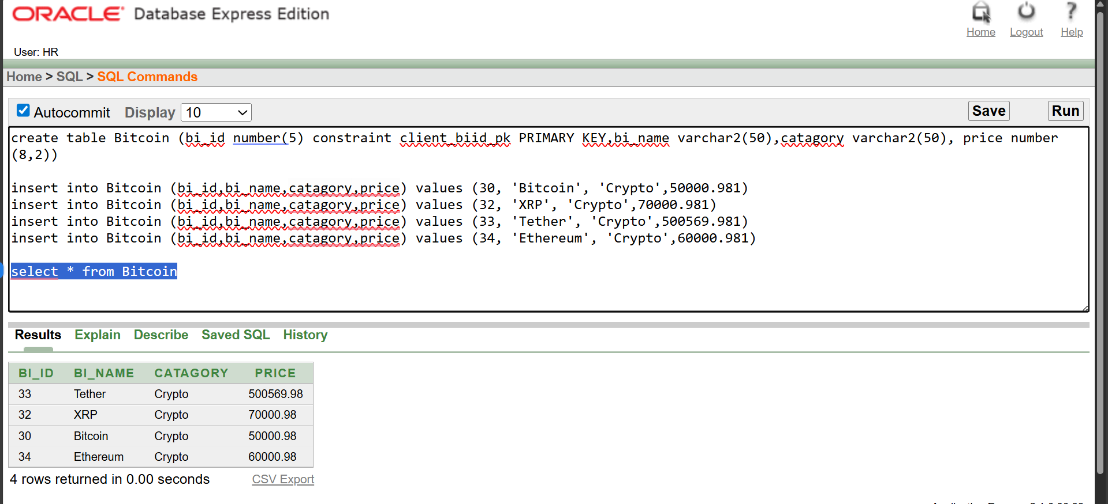insert into Bitcoin (bi_id,bi_name, category, price) values (34, 'Ethereum', 'Crypto',60000.981)

5. create table Payment (p_id number (5) constraint client_pi_pk PRIMARY KEY, p_date Date, p_type varchar2(50))

insert into Payment (p_id,p_date,p_type) values (10, TO_DATE ('2025-09-19','YYYY-MM-DD'),'Online')

insert into Payment (p_id,p_date,p_type) values (11, TO_DATE ('2025-09-5','YYYY-MM-DD'),'Online')

insert into Payment (p_id,p_date,p_type) values (12, TO_DATE ('2025-05-9','YYYY-MM-DD'),'Online')

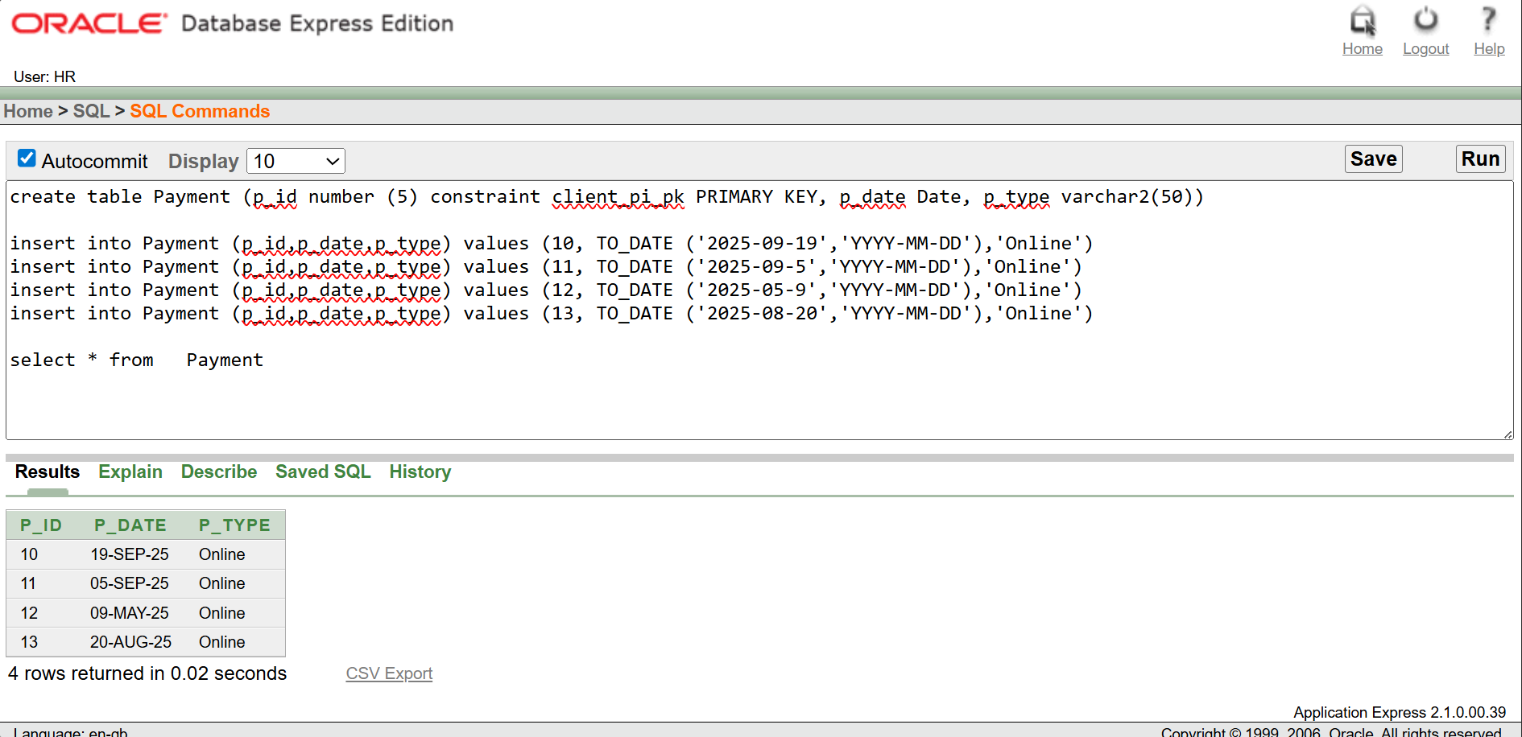insert into Payment (p_id,p_date,p_type) values (13, TO_DATE ('2025-08-20','YYYY-MM-DD'),'Online')

**Query**

1. Display the names and wallet balances of all clients whose wallet balance is less than that of the client with c_id = 103.

Ans: select c_name,wallet_balance from Clients where wallet_balance < (select wallet_balance from Clients Where c_id=103)

2. Show the names and phone numbers of all clients and brokers who have the same gender.

Ans: select C.c_name As c_name,C.c_gender,B.b_name As b_name from Clients C join Brokr B on lower (C.c_gender)=lower (B.b_gender)

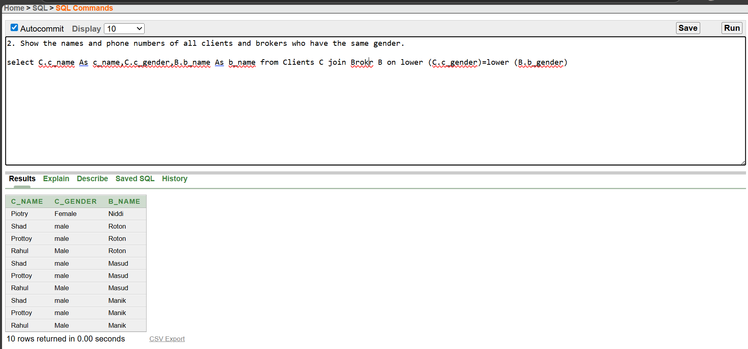

3.Show all bitcoin names whose price is less than any broker commission rate multiplied by 10,000.

Ans: select bi_name,price from Bitcoin where price < (select max(commissionRate)* 10000 from Broker)

4. Show the names and wallet balances of all male clients who have more than 10,000 in their wallet.

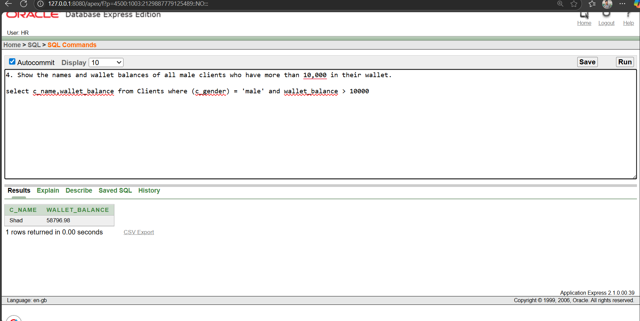Ans:select c_name,wallet_balance from Clients where (c_gender) ='male' and wallet_balance > 10000

5. Show broker name and their commission amount calculated as 5% of average wallet balance.

Ans:select b_name,(0.05*(select avg(wallet_balance) from Clients)) AS Commission_Amount from Broker  
  
  
  
  
  
  
  
  
  
  
  
  
  
  
  
  
  
**View**

**Simple View:**

1. create or replace view simple_client_view As select c_id,c_name,wallet_balance from Clients

select * from Clients

1. **Complex View:**

CREATE OR REPLACE VIEW complex_client_bitcoin_view AS SELECT c.c_id,c.c_name,c.wallet_balance,b.bi_name AS bitcoin_name,b.price AS bitcoin_price,(c.wallet_balance b.price) AS possible_unitsFROM Clients cJOIN Bitcoin b ON 1=1

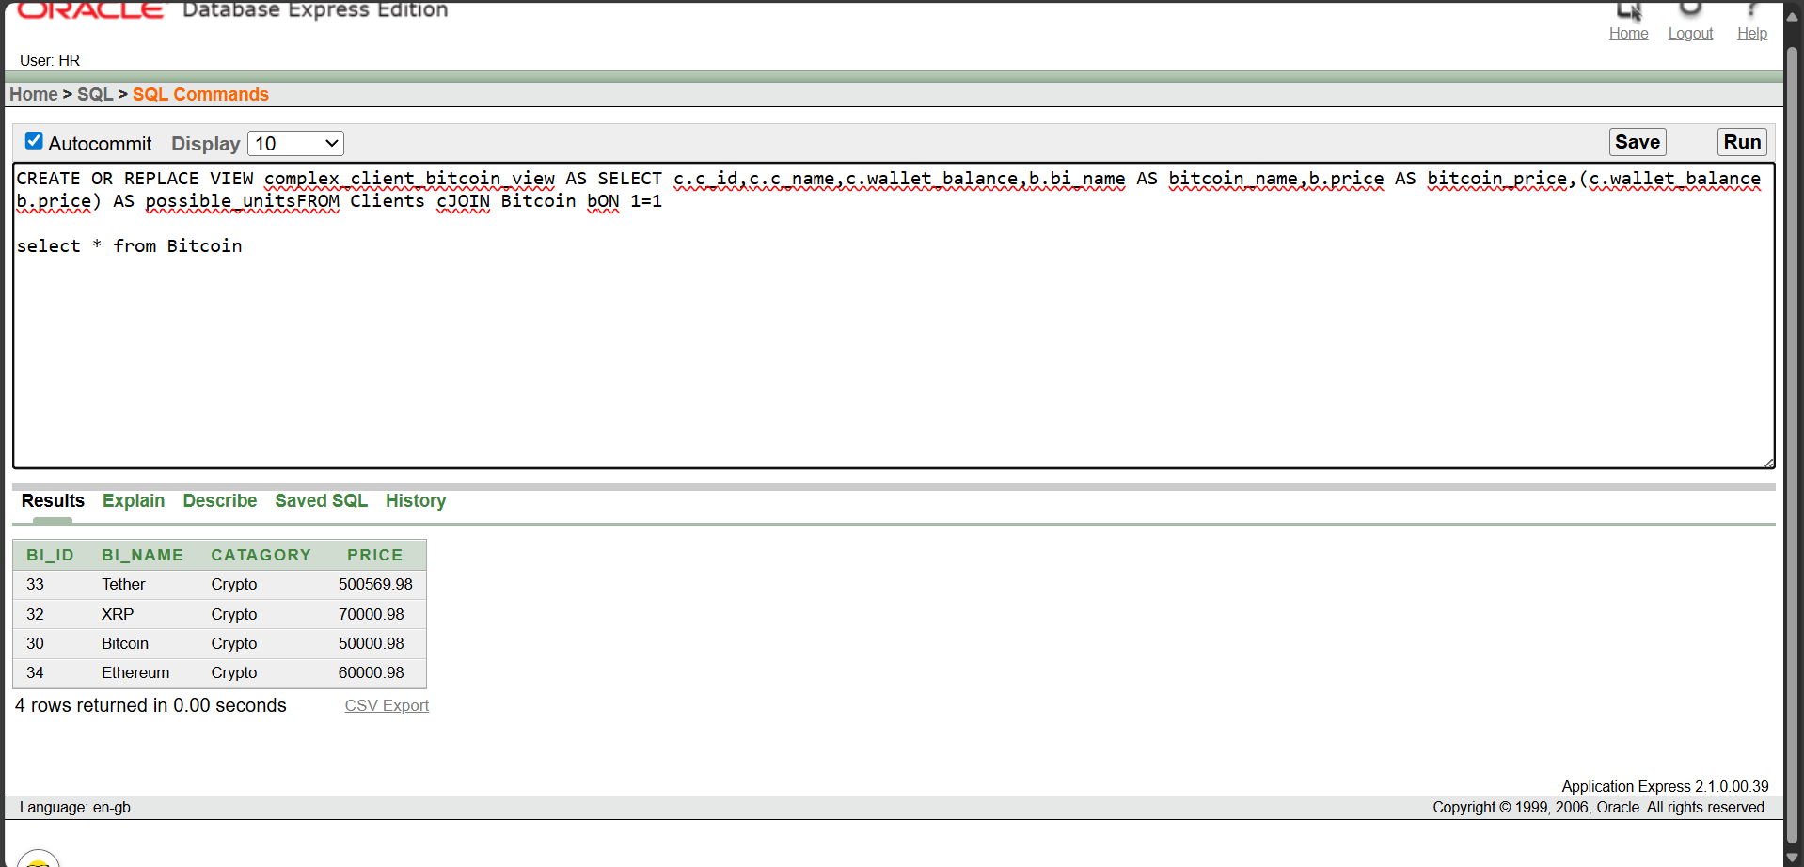select * from Bitcoin